

SIMATS ENGINEERING
Saveetha Institute of Medical and Technical Sciences
Chennai- 602105

Student Name: Abinesh H Reg. No.:192424387
Course Code: DSA0216 Slot: B
Course Name: Computer Vision with Open CV For Modern AI
Course Faculty: Dr. Senthilvadivu S & Dr. Kumaragurubaran T
Project Title: Vision-based carbon footprint estimator for smart cities
Module Photographs:
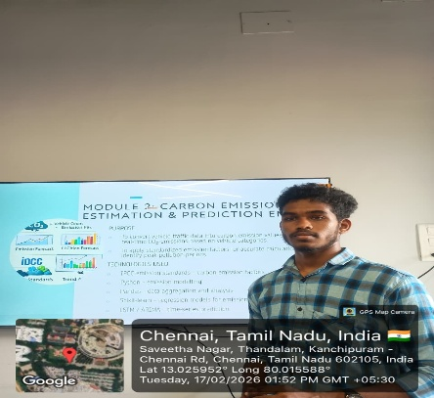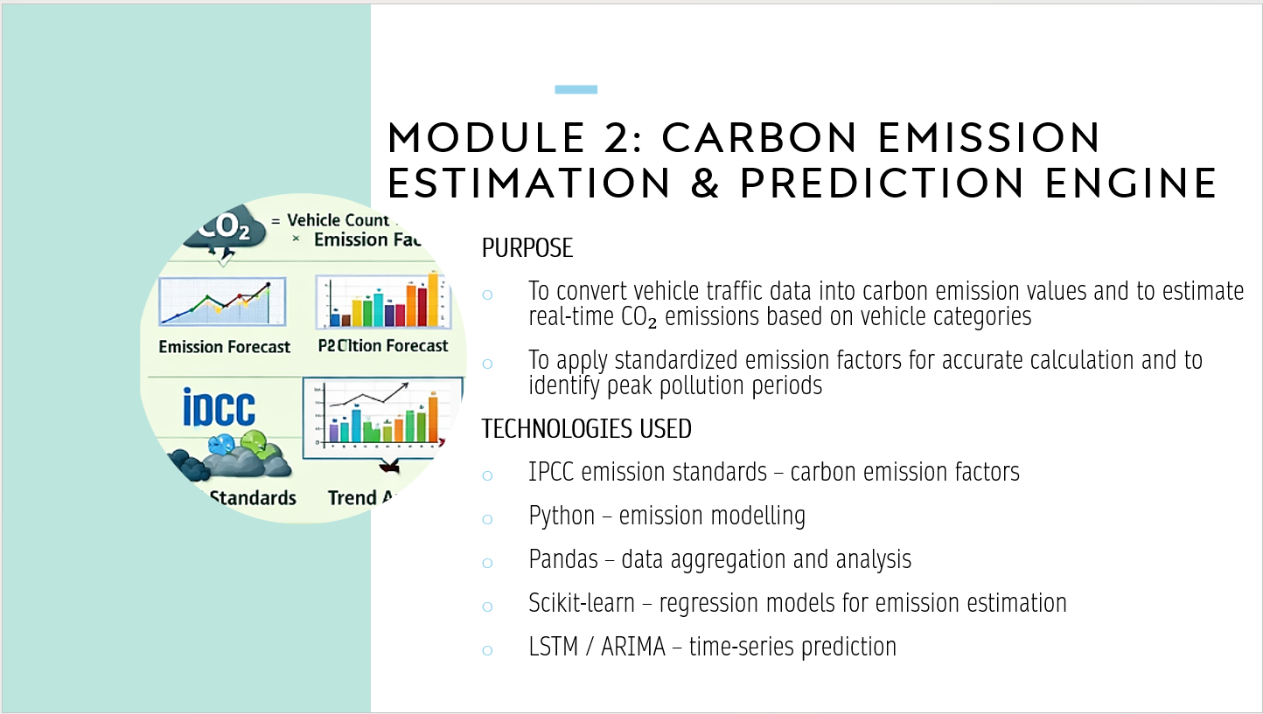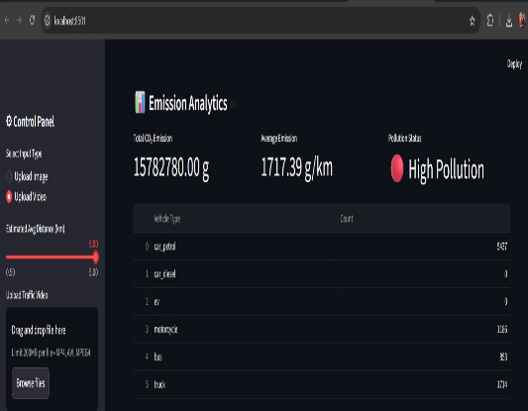

Fig 1: Photo Fig 2: module 2 Fig 3: Output
Project Description:
Smart carbon estimation and predictive analytics systems play a crucial role in smart city environmental management by transforming processed traffic insights into quantifiable emission intelligence. In this module, vision-derived traffic indicators are integrated with emission modelling techniques and statistical learning algorithms to estimate and forecast urban carbon output. This approach enables analytical systems to leverage historical emission patterns while adapting dynamically to time-based traffic variations and city-specific environmental conditions.

The dataset includes attributes such as vehicle count per category, fuel-based emission factors, average travel speed, idle duration, traffic congestion index, temporal distribution patterns, and region-wise environmental coefficients. Feature engineering techniques are employed to derive meaningful indicators such as total estimated CO₂ emissions per interval, projected emission growth trends, peak emission periods, carbon intensity per zone, and comparative environmental performance metrics.

As a result, the Carbon Emission Estimation and Prediction Engine provides a scalable and data-driven foundation for proactive environmental monitoring and intelligent decision support, enabling accurate forecasting of urban carbon patterns and supporting sustainable planning strategies for smart city development.

Student Signature Guide Signature

